1. Nodes for a doubly linked list are defined to have the following structure:

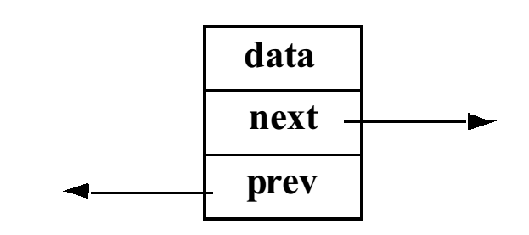

The next instance variable stores a reference to the next node in the list, and the prev instance variable refers to the previous node in the list. Below is a list of three of these nodes, along with two reference variables, n and p, that refer to specific nodes in the list.

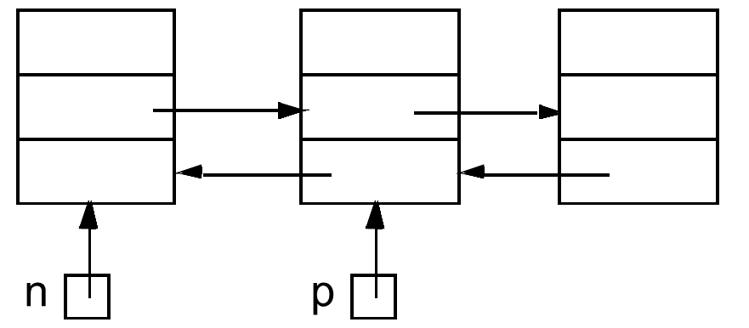

Which of the following expressions does not refer to the third node in the list?

1. p.next
2. n.next.next
3. p.prev.next
4. p.next.prev.next
5. n.next.next.prev.next
6. If class D is a derived class that inherits from class B, which of the following occurs when a D object is constructed?
7. A constructor of the D class is executed and then a constructor of the B class is executed.
8. A constructor of the B class is executed and then a constructor of the D class is executed.
9. A constructor of the D class is executed and a constructor of the B class is not executed.
10. A constructor of the B class is executed and a constructor of the D class is not executed.
11. A constructor of the D class is executed and then a constructor of the B class is executed only if it is explicitly called by the D class constructor.
12. A constructor of the D class is executed only if it is declared virtual. Otherwise, a constructor of the B class is the only constructor executed.
13. Given the same classes B and D as in the previous question, which of the following statements has/have a syntax error? (Assume both B and D have default constructors.)
14. B * b = new B;
15. D * d = new D;
16. B * d = new D;
17. D * b = new B;
18. c) and d) have syntax errors
19. none of the above statements have syntax errors.
20. Dynamic binding refers to the process of ____________________________________.
21. giving the compiler specific instructions as to which function to use
22. delaying until run-time the choice of the appropriate function to use
23. using the scope resolution operator to decide which function to use
24. using the keyword new to allocate memory for the function code
25. Circle the correct answer

struct ListNode

{

float volume;

ListNode* link;

};

ListNode* headPtr;

ListNode* ptr;

float searchVal;

Assume that headPtr is the external pointer to a linked list of many nodes. Which code segment below searches the list for the first occurrence of searchVal, leaving ptr pointing to the node where it was found? (Assume searchVal is definitely in the list.)

a. ptr = headPtr;

while (volume != searchVal)

ptr = link;

b. ptr = headPtr;

while (ptr.volume != searchVal)

ptr = ptr.link;

c. ptr = headPtr;

while (ptr->volume != searchVal)

ptr++;

d. ptr = headPtr;

while (ptr->volume != searchVal)

ptr = ptr->link;

e. ptr = headPtr->volume;

while (ptr != searchVal)

ptr = ptr->link;

1. To indicate that a member function of a class is pure virtual
2. you must put = 0 where the body of the function would go.
3. you must include the <pure> header file.
4. you use the keywords pure virtual
5. All of the above
6. None of the above
7. What is the output of the following program?

#include <iostream>

using namespace std;

int main(){

try{

try{

throw 20;

}

catch (int n){

cout << "Inner Catch\n";

throw;

}

}

catch (int x){

cout << "Outer Catch\n";

}

return 0;

}

1. Which function gets called in the following code?

class Person

{

public: virtual void print( ) const;

};

class Student : public Person

{

public: void print( ) const;

};

int main( ) {

Person *x = new Student( );

x->print( );

return 0;

}

1. Person::print()
2. Student::print()
3. void print()
4. No function gets called, the call results in a segmentation fault
5. Given an integer $n > 0$, write a recursive C++ function that returns the sum of the squares of 1 through $n$.
6. What is the output of the following program.

#include <iostream>

using namespace std;

template <class T>

class Test

{

private:

T val;

public:

static int count;

Test() { count++; }

};

template<class T>

int Test<T>::count = 0;

int main()

{

Test<int> a;

Test<int> b;

Test<double> c;

cout << Test<int>::count << endl;

cout << Test<double>::count << endl;

return 0;

}

1. Suppose a program has the following class declarations:  
   class Shape  
   {

private:

double area;

public:

void setArea(double a)

{ area = a;}

double getArea()

{ return area;}

};

class Circle: public Shape

{

private:

double radius;

public:

void setRadius(double r)

{ radius = r;

setArea( 3.14 * r * r);}

double getRadius()

{ return radius; }

};

Answer the following questions concerning these classes:

1. When an object of the Circle class is created, what are its private members?
2. When an object of the Circle class is created, what are its public members?
3. What members of the Shape class are not accessible to member functions of the Circle class?
4. Suppose a program has the following class declaration:

// Declaration of CheckPoint class.

Class CheckPoint

{

private:

int a;

protected:

int b;

int c;

void setA(int x) { a = x;}

public:

void setB( int y) { b = y;}

void setC( int z) { c = z;}

};

Answer the following questions regarding the class:

1. Suppose another class, Quiz, is derived from the CheckPoint class. Here is the first line of its declaration:

class Quiz : private CheckPoint

Indicate whether each member of the CheckPoint class is private, protected, public, or inaccessible:

a

b

c

setA

setB

setC

1. Suppose the Quiz class, derived from the CheckPoint class, is declared as class Quiz : protected CheckPoint

Indicate whether each member of the CheckPoint class is private, protected, public, or inaccessible:

a

b

c

setA

setB

setC

1. Suppose the Quiz class, derived from the CheckPoint class, is declared as class Quiz : public CheckPoint

Indicate whether each member of the CheckPoint class is private, protected, public, or inaccessible:

a

b

c

setA

setB

setC

1. Suppose the Quiz class, derived from the CheckPoint class, is declared as class Quiz : CheckPoint

Is the CheckPoint class a private, public, or protected base class?

1. What will the following program display?

#include <iostream>

using namespace std;

class First

{

protected:

int a;

public:

First( int x = 1)

{ a = x; }

virtual void twist()

{ a *= 2;}

int getVal()

{ twist(); return a; }

};

Class Second : public First

{

private:

int b;

public:

Second(int y = 5)

{ b = y; }

virtual void twist()

{ b *= 10; }

};

int main()

{

First object1;

Second object2;

cout << object1.getVal() << endl;

cout << object2.getVal() << endl;

return 0;

}

1. Which code fragment(s) could be inserted in the blank in order to safely initialize each element of A to zero?

int* p = &A[0];

for (int Idx = 0; Idx < Size; Idx++, p++){

____________________;

}

1) *A = 0; 2) A[Idx] = 0; 3) *p = 0; 4) *Idx = 0; 5) All of the above

6) 1 and 2 only 7) 1 and 3 only 8) 2 and 3 only 9) 1 and 4 only 10) None of these

1. ________ functions are dynamically bound by the compiler.
2. Virtual
3. Constructor
4. Destructor
5. Static
6. None of the above
7. Class templates allow you to create one general version of a class without having to
8. use private members.
9. use member functions.
10. duplicate code to handle multiple data types.
11. write any code.
12. None of the above
13. Polymorphism is when ________ in a class hierarchy perform differently, depending upon the class of the object making the call.
14. member functions
15. derived class constructors
16. base class constructors
17. derived class destructors
18. None of the above
19. True/False: Pointers to a base class may be assigned the address of a derived class object.
20. Assume we have the following class definition from the IntVector class.

|  |
| --- |
| class IntVector{  private:  unsigned sz;  unsigned cap;  int *data;  public:  IntVector();  IntVector( unsigned size );  IntVector( unsigned size, int value );  ~IntVector();  void doublesArray();  }; |
| 1. Write a definition for a function called appendDouble, that appends twice the value of the contents of the array. Ex. An array containing 2, 16, -12, 59 would contain 2, 16, -12, 59, 4, 32, -24, 128 |